|  |
| --- |
| ΒΔ εταιρείας αεροπορικών μεταφορών 2  Διαχείριση Δεδομένων Ι |
| Μαρίνος Κουβαράς ap23011 |
| 19 Ιανουαρίου 2024 |

# **Πίνακας Περιεχομένων**

Πίνακας Περιεχομένων 2

Βήματα Σχεσιακού Μοντέλου 2

Βήμα 1 2

Βήμα 2 3

Βήμα 3 4

Βήμα 4 5

Σχεσιακό Μοντέλο 6

Στοιχεία της ΒΔ - Σχέσεις 7

# 

# 

# 

# 

# **Βήματα Σχεσιακού Μοντέλου**

## **Βήμα 1**

Δημιουργούμε μία σχέση για κάθε τύπο οντοτήτων.

| AIRPLANE | **Aircraft Register** | Airplane_Type | ΜΑΧ_Passengers | MAX_Weight | Fuel_Quantity | Fuel_Consumption_per_hour | Takeoff_Distance | Landing_Distance | Cruising_Speed |
| --- | --- | --- | --- | --- | --- | --- | --- | --- | --- |

| AIRPORT | **ICAO** | Longitude | Latitude | Runway_Heading | Runway_Length |
| --- | --- | --- | --- | --- | --- |

| ROUTE | **Route _ID** | Departure_Date_Time | Route Distance |
| --- | --- | --- | --- |

| EMPLOYEE | **Employee_ID** | Title | Name | Surname | Qualification | Type_Rating | Hours_of_Flight | Payment |
| --- | --- | --- | --- | --- | --- | --- | --- | --- |

| PASSENGER | **Passenger ID** | Title | Name | Surname | Birthdate | Email |
| --- | --- | --- | --- | --- | --- | --- |

## **Βήμα 2**

Για κάθε δυαδική σχέση 1:1 το πρωτεύον κλειδί της μίας γίνεται ξένο κλειδί της άλλης.

* **Airplane** → *FLIES →* **Route**
  + 1:1
  + Airplane ολική συμμετοχή.
  + Route ολική συμμετοχή.

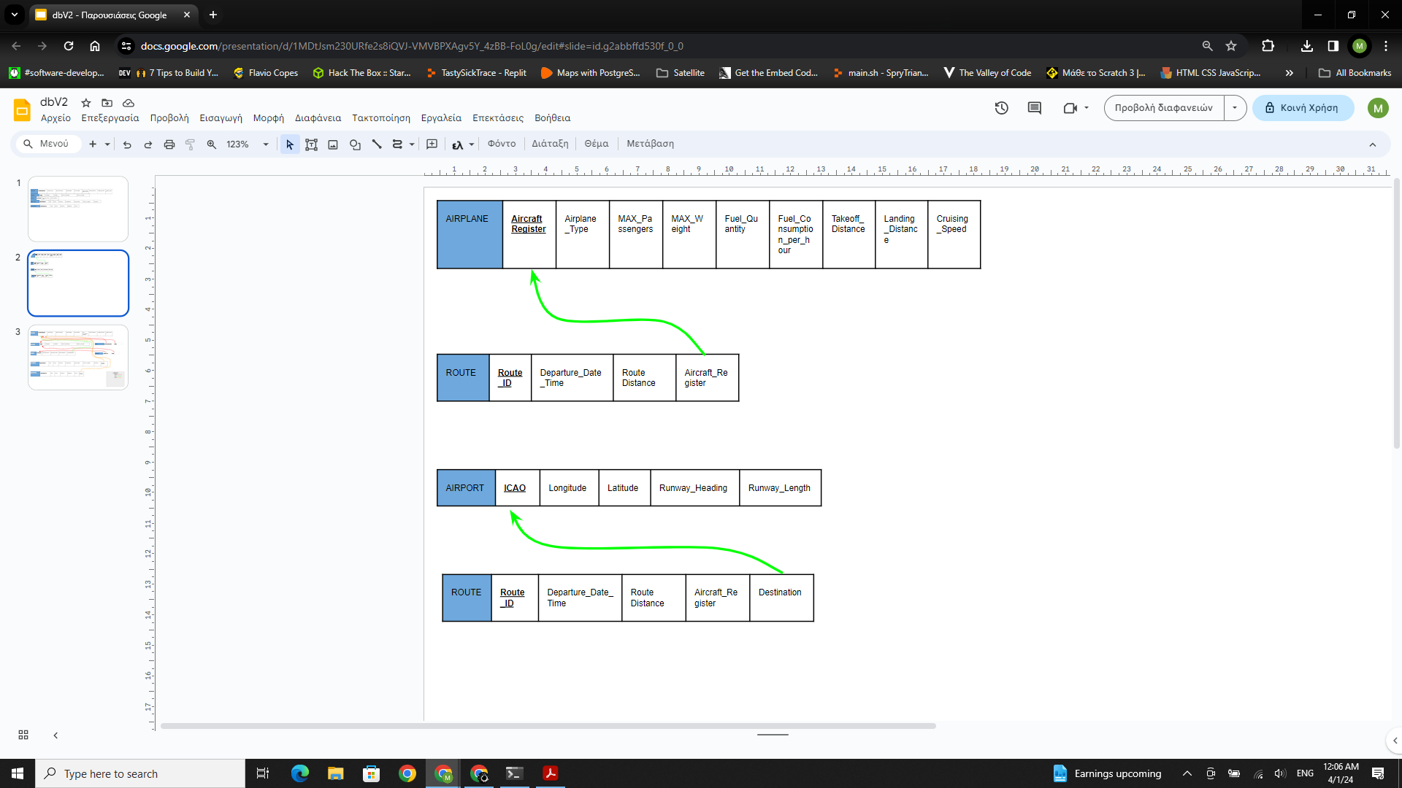

* **Route** → *CONNECTS* → **Airports**
  + 1:1
  + Route ολική συμμετοχή.
  + Airport ολική συμμετοχή.



## **Βήμα 3**

Για κάθε δυαδική συσχέτιση 1:Ν το πρωτεύον κλειδί της (1) γίνεται ξένο κλειδί της (Ν).

* **Employee** → WORKS → **Airplane**
  + 1:Ν
  + Employee ολική συμμετοχή.
  + Airplane ολική συμμετοχή.

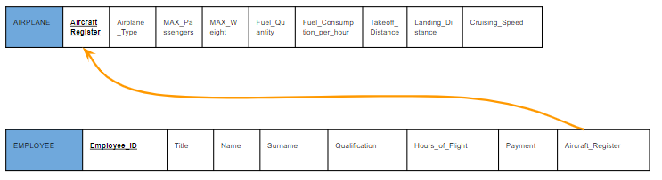

* **Passenger** → BOARDS → **Airplane**
  + 1:Ν
  + Passenger ολική συμμετοχή.
  + Airplane ολική συμμετοχή.

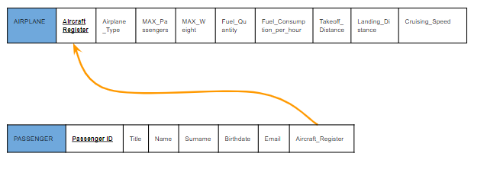

* **Passenger** → TRAVELS → **Route**
  + 1:Ν
  + Passenger ολική συμμετοχή.
  + Route ολική συμμετοχή.

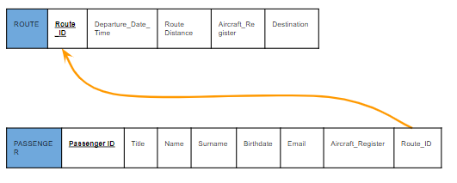

## **Βήμα 4**

Για κάθε δυαδική σχέση Μ:Ν δημιουργούμε νέα σχέση.

* **Airplane** → *LANDS* → **Airport**
  + Μ:Ν
  + Airplane μερική συμμετοχή.
  + Airport μερική συμμετοχή.

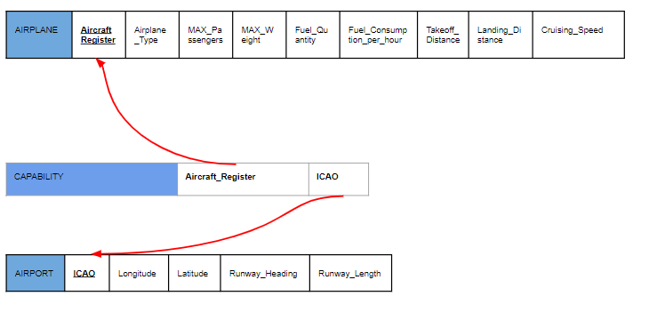

## **Σχεσιακό Μοντέλο**

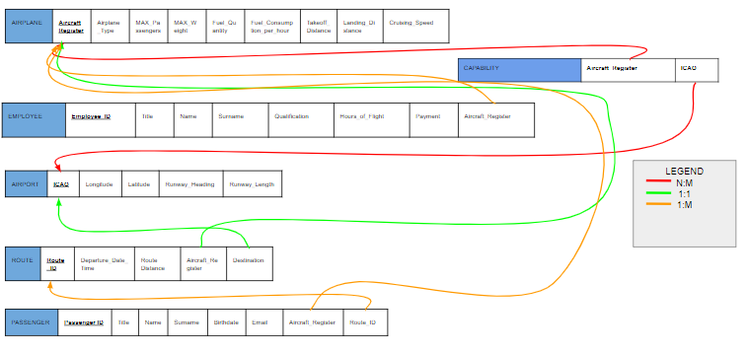

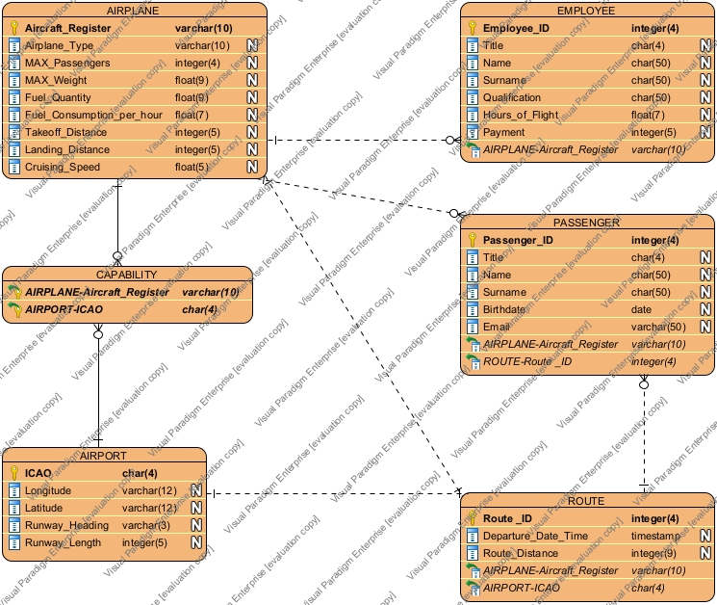

# **Στοιχεία της ΒΔ - Σχέσεις**

| AIRPLANE | **Aircraft Register** | Airplane_Type | ΜΑΧ_Passengers | MAX_Weight | Fuel_Quantity | Fuel_Consumption_per_hour | Takeoff_Distance | Landing_Distance | Cruising_Speed |
| --- | --- | --- | --- | --- | --- | --- | --- | --- | --- |
|  | sx01 | A220 | 160 | 156000 | 21508 | 1800 | 4800 | 4100 | 0.8 |
|  | sx02 | A320 | 186 | 206000 | 27200 | 2100 | 5997 | 4593 | 0.8 |
|  | sx03 | A330 | 406 | 445000 | 139090 | 5200 | 7280 | 4200 | 0.8 |
|  | sx04 | A350 | 480 | 624000 | 166488 | 5800 | 8500 | 6561 | 0.8 |
|  | sx05 | A380 | 853 | 1268000 | 320000 | 11400 | 9800 | 7000 | 0.8 |

| AIRPORT | **ICAO** | Longitude | Latitude | Runway_Heading | Runway_Length |
| --- | --- | --- | --- | --- | --- |
|  | LGEL | N38 04.17 | E023 33.25 | 36R | 8981 |
|  | LGPZ | N38 55.53 | E020 45.90 | 07R | 9814 |
|  | LGAL | N40 51.35 | E025 57.37 | 07 | 8471 |
|  | LGAV | N37 56.20 | E023 56.67 | 03R | 13123 |
|  | LGKP | N35 25.27 | E027 08.75 | 12 | 7871 |
|  | LGRX | N38 09.07 | E021 25.53 | 36L | 10997 |

| ROUTE | **Route _ID** | Departure_Date_Time | Route Distance | Aircraft_Register | Destination |
| --- | --- | --- | --- | --- | --- |
|  | 1 | 01/01/2024 8:00 | 120 | sx01 | LGEL |
|  | 2 | 01/01/2024 8:00 | 180 | sx02 | LGPZ |
|  | 3 | 01/01/2024 8:00 | 90 | sx03 | LGAL |
|  | 4 | 01/01/2024 8:00 | 110 | sx04 | LGKP |
|  | 5 | 01/01/2024 8:00 | 240 | sx05 | LGRX |

| EMPLOYEE | **Employee_ID** | Title | Name | Surname | Qualification | Hours_of_Flight | Payment | Aircraft_Register |
| --- | --- | --- | --- | --- | --- | --- | --- | --- |
|  | 1 | Ms. | Waylon | Nelson | Pilot | 500 | 1000 | sx01 |
|  | 2 | Ms. | Messiah | Leonard | Pilot | 800 | 1000 | sx02 |
|  | 3 | Mrs. | Analia | Coleman | Pilot | 830 | 1000 | sx03 |
|  | 4 | Mrs. | Elise | Stafford | Hostess | 200 | 800 | sx04 |
|  | 5 | Ms. | Sam | Phillips | Hostess | 640 | 800 | sx05 |

| PASSENGER | **Passenger ID** | Title | Name | Surname | Birthdate | Email | Aircraft_Register | Route_ID |
| --- | --- | --- | --- | --- | --- | --- | --- | --- |
|  | 1 | Ms. | Zayn | Taylor | 01/01/1980 | steve@me.com | sx01 | 1 |
|  | 2 | Mrs. | Laurel | Snyder | 02/02/1981 | andrei@yahoo.ca | sx02 | 2 |
|  | 3 | Ms. | Ahmir | Neal | 03/03/1983 | bockelboy@aol.com | sx03 | 3 |
|  | 4 | Ms. | Leonidas | Randolph | 04/04/1984 | parkes@gmail.com | sx04 | 4 |
|  | 5 | Ms. | Presley | Parks | 05/05/1985 | floxy@msn.com | sx05 | 5 |

| CAPABILITY | **Aircraft_Register** | **ICAO** |
| --- | --- | --- |
|  | sx01 | LGEL |
|  | sx02 | LGPZ |
|  | sx03 | LGAL |
|  | sx04 | LGKP |
|  | sx05 | LGRX |

1. **AIRPLANE**
   1. Aircraft_Register [*VARCHAR(10)*]
   2. Airplane_Type [*VARCHAR(10)*]
   3. ΜΑΧ_Passengers [NUMBER(4,0)]
   4. MAX_Weight [NUMBER(9,2)]
   5. Fuel_Quantity [NUMBER(9,2)]
   6. Fuel_Consumption_per_hour [NUMBER(7,2)]
   7. Takeoff_Distance [NUMBER(5,0)]
   8. Landing_Distance [NUMBER(5,0)]
   9. Cruising_Speed [NUMBER(5,2)]
2. **AIRPORT**
   1. ICAO [CHAR(4)]
   2. Longitude [VARCHAR(12)]
   3. Latitude [VARCHAR(12)]
   4. Runway_Heading [VARCHAR(3)]
   5. Runway_Length [NUMBER(5,0)]
3. **ROUTE**
   1. Route _ID [NUMBER(4,0)]
   2. Departure_Date_Time [TIMESTAMP]
   3. Route_Distance [NUMBER(9,0)]
   4. Aircraft_Register (FK)
   5. Destination (FK)
4. **EMPLOYEE**
   1. Employee_ID [NUMBER(4,0)]
   2. Title [CHAR(4)]
   3. Name [CHAR(50)]
   4. Surname [CHAR(50)]
   5. Qualification [CHAR(50)]
   6. Hours_of_Flight [NUMBER(7,2)]
   7. Payment [NUMBER(5,0)]
   8. Aircraft_Register (FK)
5. **PASSENGER**
   1. Passenger_ID [NUMBER(4,0)]
   2. Title [CHAR(4)]
   3. Name [CHAR(50)]
   4. Surname [CHAR(50)]
   5. Birthdate [DATE]
   6. Email [VARCHAR(50)]
   7. Aircraft_Register(FK)
6. **CAPABILITY**
   1. Aircraft_Register [VARCHAR(10)]
   2. ICAO [CHAR(4)]